WALT: find change from any amount.
Mixed up starter
1) 65 - ___ = 22
2) ¾ + 0.25 =
3) Find 1/5 of 40
4) What is the difference between 12 and 78?
5) 16 less than 5
6) ___= 784 - 257
7) 3257 + 1099
8) 36 x 9=
9) Write 4 factors of 12
10) How many 1/8 in 2 wholes?

Task 1: Answer the word problems below.

- Annie has £15 to spend at the theme park. She rides on the roller coaster which costs £4.34 Then she rides on the big wheel which costs £3.85. How much change does she get?

Answer=
- Jemima was given £5 by her mum to buy some sweets. She bought a lolly for 49p and a packet of jellies for £1.76. How much change does she get?

Answer=
- Thomas won £20 in a raffle. He gave his brother £10 and then bought himself some fish and chips for £4.50. How much does he have left?

Answer=

Task 2: Items have been purchased and change has been given. Can you check if the change is correct or not?
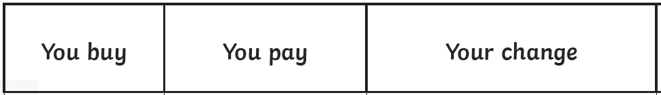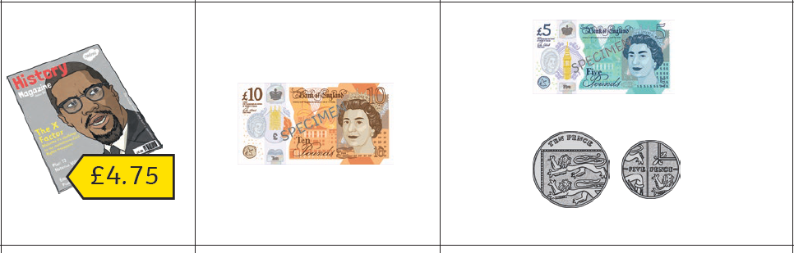
Answer=

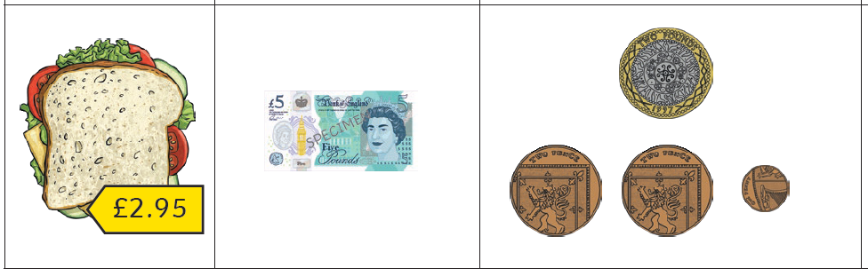

Answer=

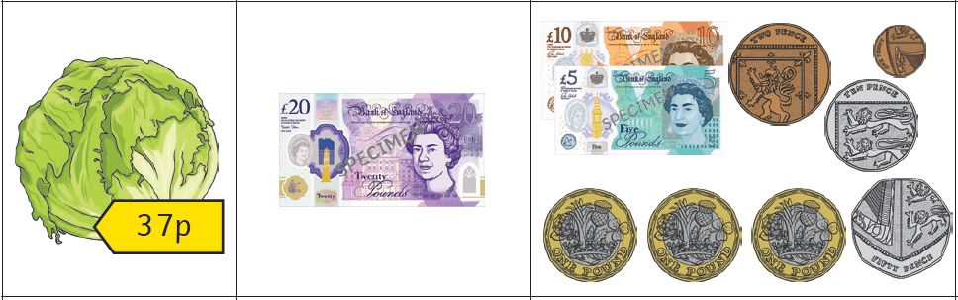

Answer=

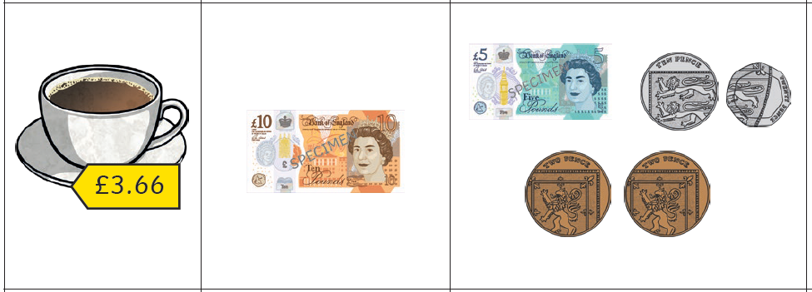

Answer=

Task 3: Reasoning – explain!
John has £10 and he wants to buy a toy which costs £4.76 and a book which costs £5.82. Sarah says he doesn’t have enough. He thinks he does. Who is right? Can you prove it?

Answer =

Challenge
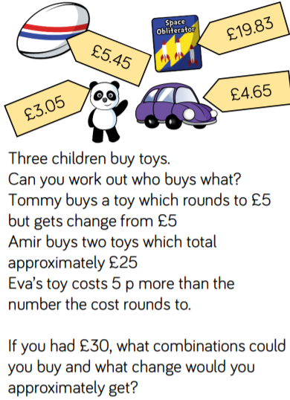

Tommy =
Amir =
Eva =

Your combination =

