TASK 1: Can you complete these sentences? Tip - Use your multiplication skills!
- There are _____ seconds in five minutes.
- There are _____ minutes in three hours.
- There are _____ hours in a weekend.
- There are _____ hours in a week.
- There are _____ days in a fortnight.
- There are _____ days in a year.
- There are _____ days in 3 years.
- There are _____ weeks in a year.
- There are _____ years in a decade.
- There are _____ years in a century.
Ch: There are _____ minutes in a day.

TASK 2 – Draw lines to connect the matching times
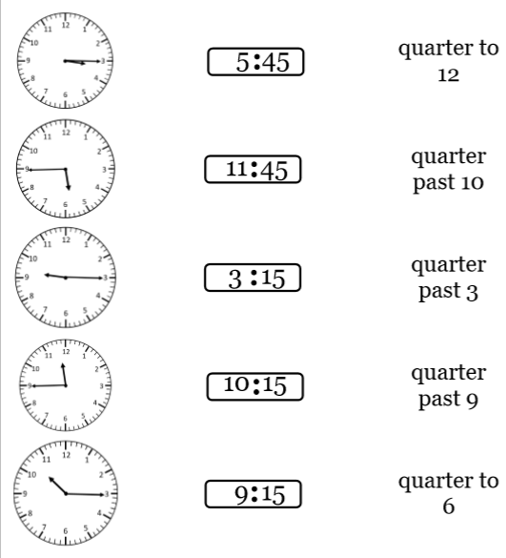

TASK 3 – Problem solving and reasoning
- I spend 245 seconds doing times table practice. How many minutes and seconds is this?

- True or False? Explain your answers using APE.

- 3 days > 72 hours

- 2 ½ years = 29 months

- 11 weeks 4 days < 10 weeks 14 days

- Complete the table.
Number of days | Number of weeks
 | 5
56
 | 14
147
 | 12
77

- Five friends run a race. Their times are shown in the table.

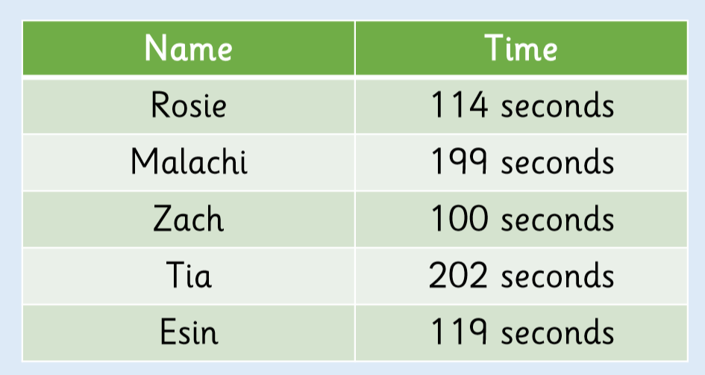

- Which child finished the race closest to two minutes?

- What was the difference between the fastest time and the slowest time? Give your answer in minutes and seconds.

- Rosie says – “I can just change seconds into minutes by multiplying by 60.” Is she right? Explain your answer.

