The people in charge of keeping St. Saviour’s children safe are:
Designated Safeguarding Leads
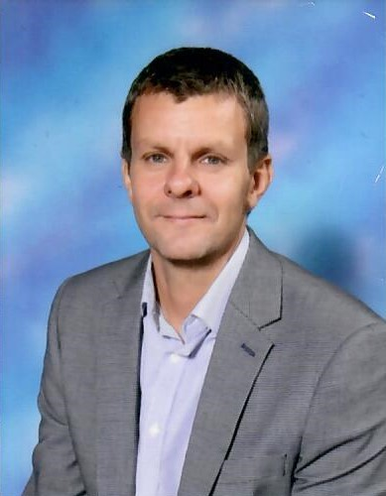 | 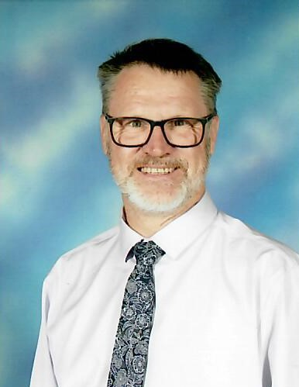
Mr Bonell DSL | Mr Arnold Deputy DSL
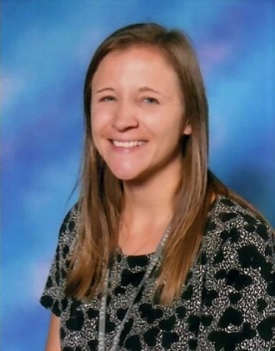 | 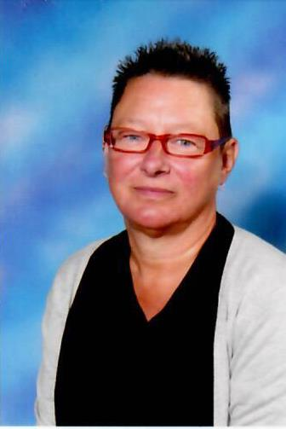
Mrs Tift Deputy DSL | Mrs Theobald-Grainger Deputy DSL
If you are scared or worried about something at school, home or anywhere, you can speak to: your teacher or any member of staff.
If you have a worry, tell an adult, don’t keep it a secret.
Tell an adult if someone is:
- Bullying you
- Saying things which you do not like or that upset you - at home or school
- Touching you in a way that makes you feel uncomfortable
- Trying to give you tablets, cigarettes, drugs or alcohol
- Hitting or hurting you
- Taking your things
- Saying or sending you unkind messages
- A stranger is messaging you
- Not looking after you properly

