End Points for Writing Year Group 5
Blue = Recap from previous years Green = Introduce Orange = Revisit
 | T1 | T2 | T3 | T4 | T5 | T6
Key texts and contexts | 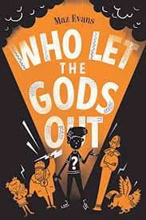 | 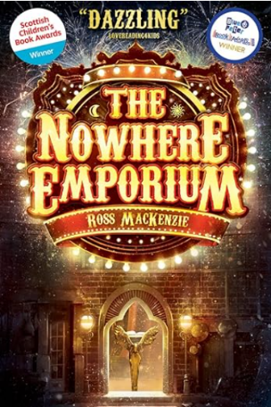  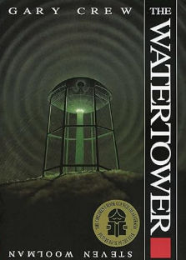 | 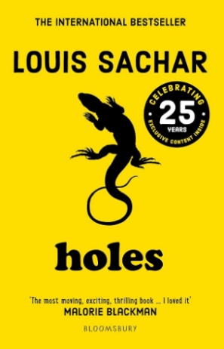 | 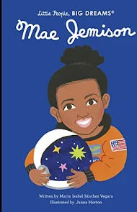  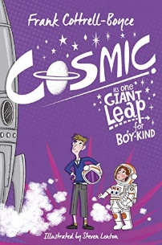 | 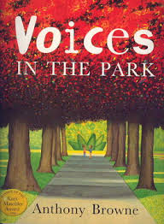 | 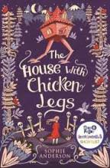
Supporting texts | LS + Greek myths  LS + Ancient Greece (Stage 4) | Poetry: I don’t like poetry  Poetry: When the teacher turns her back  Poetry: I want to be bad | Texts linked with racism and civil rights (Lit Shed +)  Poem – Caged Bird by Maya Angelou (Ashely Booth resources) 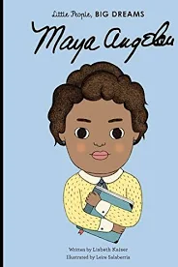 | Non -fiction: LS+ Space  Non -fiction: LS+ Living things  Range of biographies | 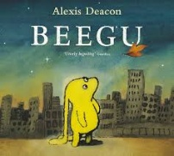 | Folktales from different cultures
Handwriting | Form lower-case letters correctly: correct size relative to one another  Join letters: use diagonal and horizontal strokes to join letters and understand which letters, when adjacent to one another, are best left unjoined  Size capital letters correctly: Write capital letters and digits of the correct size, orientation and relationship to one another and to lower case letters: capitals must be to the top of the line  Use correct spacing: spacing between words to reflect the size of the letters. Ascenders and descenders should not meet  Write legibly and fluently: decide whether or not to join specific letters; choose the writing implement that is best suited for a task.  Handwriting intervention groups.  Develop fluent and legible style.  Practise as required and check accuracy on a daily basis.  Assess handwriting progression after Independent Write.
Phonics into spelling  COVID RECOVERY PLAN | Revision of rules 5-8: Split digraph, -ed, -ing etc. suffixes  Revision of rules 15-17 (this will be new to lower spellers): Range of suffixes after a ‘y’ | Revision of KS1 and Yr 3/4 Homophones and near homophones  INTRODUCE rule 18: contractions  INTRODUCE rule 19: sion / tion | INTRODUCE Rule 20: Prefixes  Revision of EXCEPTION 1: The /I/ sound spelt ‘y’ other than at the end of words e.g. myth  Revision of EXCEPTION 2: The ‘uh’ sound spelt ‘ou’ e.g. young | Revision of Rule 21: sure / ture ending  INTRODUCE EXCEPTION 3: Words with ‘ch’ making the ‘sh’ or ‘k’ sound. E.g. chemist, chef  INTRODUCE Rule 22: Suffix –ous, -ious | Rule 23: tial / cial  Rule 24: -able / -ible, -ably / -ibly  Homophones and near homophones (secure KS1 and y3/4 first, then move on to Year 5/6 homophones) | EXCEPTION 4: Words containing ‘ough’ e.g. bought, through  Rule 25: cian and ssion  REVISION
Assessed Writing | Instructions (2 weeks)  Setting description 3 weeks (underworld / Elysium)  Non-chronological report 3 weeks (Greek God / mythical creature)  8 WEEKS | Poetry – different forms 2 weeks  Short character description unit 2 weeks  Story writing – SUSPENSE 3 weeks  7 WEEKS | Persuasive letter (from Stanley to judge etc) 3 weeks  Setting description / Flashbacks 1 week  Dialogue development 2 WEEKS (The Warden and Stanley)  6 WEEKS | Biography – Mae Jemison. Famous space explorers. Tim Peake and Katherine Johnson 3 weeks  Look at Literacy Shed + unit  Argument/discussion 3 weeks – should people explore Space? Is Space exploration a waste of money?  6 WEEKS | Diary – different voices – Charles, Dad, Mum and Smudge  Newspapers – Beegu – alien landing  5 WEEKS | Character description (Baba Yaga/Marinka)  2 weeks  3 weeks Story (own modern twist on an explanation folk tale?)  2 weeks POETRY  Free verse and performance poetry  7 WEEKS
grammar/ terminology | Capital letter  Vowel, consonant  A/an  Suffix, word family  Singular, plural  Noun, noun phrase, adjective.  Verb, adverb, adverbial [phrase].  Coordinating conjunctions.  Modal verb  Statement, question, command, exclamation.  Noun/pronoun verb agreement (eg. we were not we was).  Subordinating conjunctions.  Clause, subordinate clause. | Direct speech  Pronoun  Possessive pronoun  Plural vs. possessive ‘s’  Subordinating conjunctions.  Clause, subordinate clause.  Determiner  Relative pronoun  Relative clause | Prefix, word families (Exception 2)  Verb prefixes (eg. dis, mis, de, over, re).  Prefixes and suffixes to change word classes (eg. noun to adj.).  Modal verb | Pronoun  Possessive pronoun  Relative pronoun  Relative clause  Modal verb  Dashes for parenthesis | Direct speech (if including in newspaper report)  Reported speech  Noun/pronoun verb agreement (eg. we were not we was).  Ambiguity | Direct speech  Pronoun  Possessive pronoun  Relative pronoun  Relative clause  Cohesion  Suffixes to convert nouns or adj. to verbs (eg. -ate, -ise, -ify).
Punctuation | Capital letter to start a sentence and for proper nouns.  Use a range of end punctuation: full stops, question marks, exclamation marks.  Use commas after fronted adverbials  Commas in a list  Brackets for parenthesis | Commas in a list  Inverted commas for direct speech: Secure reporting clause at the start e.g. Sarah yelled, “Hello!”  Commas for parenthesis (inc. relative clauses)  Commas to separate clauses subordinate clauses (if before a main clause)  Apostrophes for possession | Commas in a list  Capital letter When to use it for mum/dad, aunt/uncle etc. | Commas to separate clauses subordinate clauses (if before a main clause)  Commas for parenthesis (inc. relative clauses) | Commas to clarify meaning or avoid ambiguity e.g. Don’t eat, children | Inverted commas for direct speech: Teach pupils to use inverted commas and related punctuation for end e.g. “Hello!” yelled Sarah. Progress to adding character detail in a range of different ways.  Commas for parenthesis (inc. relative clauses)
sentence building | Statement, question, command  Expanded noun phrases: modifying adjectives, nouns and prepositional phrases e.g. the beautiful, blue butterfly with white spots; the large lion next to the fence  Coordinating conjunctions: or, and, but, so, for, yet  Conjunctions specifically for Instructions:  When, before, after, while, until  Conjunctions specifically for non-chron:  If, otherwise, unless, so  Subordinating conjunctions: because, when, if, as, before, after, while, although, even though  Adverbs and fronted adverbials:  HOW: ____ly and _____ly, WHEN: just then, after that, later on  Prepositional phrases  Organise ideas into sentences: correct sentences that are appropriate to the task  Modal verbs to indicate degrees of possibility: e.g. may, must | Subordinating conjunctions: because, when, if, as, before, after, while, although, even though  Conjunctions specifically for narrative:  As, while, but, although  Expanded noun phrases: modifying adjectives, nouns and prepositional phrases e.g. the beautiful, blue butterfly with white spots; the large lion next to the fence  Adverbs and fronted adverbials:  HOW: ____ly and _____ly, WHEN: just then, after that, later on  Relative clauses: starting with who, which, where and that | Adverbs to indicate degrees of possibility: e.g. perhaps, surely  Standard English including non/pronoun verb agreement and pronouns  Conjunctions: expressing time, place, cause (when, before, after, while, so, because etc.). | Adverbs to indicate degrees of possibility: e.g. perhaps, surely  Increasing range of subordinating conjunctions: New: unless, once, otherwise  Relative clauses: starting with who, which, where and that  Standard English including non/pronoun verb agreement and pronouns | Standard English including non/pronoun verb agreement and pronouns | Use expanded noun phrases to convey complicated information concisely: modifying adjectives, nouns, prepositional phrases, relative pronouns, e.g. the beautiful, blue butterfly with white spots which was fluttering around the garden; the large lion that was lying down next to the fence  Relative clauses: starting with who, which, where and that
text building | Write a clear beginning, middle and end  Past and present tense (correct and consistent use)  Use adverbials of time to sequence events: (e.g. next, later, just then, after that, later on, a few ___ later)  Use organisation devices to structure the text and guide the reader (headings, subheadings, bullet points) | Sequence sentences to form short narratives  Paragraphs to organise ideas around a theme  Past and present tense (correct and consistent use)  Maintain 1st and 3rd person | Paragraphs to organise ideas around a theme  Maintain 1st and 3rd person | Paragraphs to organise ideas around a theme  Link ideas within and across paragraphs (adverbials, pronouns)  Maintain past and present tense  Avoid repetition: Use pronouns and nouns to aid cohesion and avoid repetition, e.g. dog, it, animal, pet etc.  Use adverbials of time to sequence events: (e.g. next, later, just then, after that, later on, a few ___ later)  Maintain 1st and 3rd person  Use organisation devices to structure the text and guide the reader (headings, subheadings, bullet points) | Maintain past and present tense  Avoid repetition: Use pronouns and nouns to aid cohesion and avoid repetition, e.g. dog, it, animal, pet etc.  Use adverbials of time to sequence events: (e.g. next, later, just then, after that, later on, a few ___ later)  Use organisation devices to structure the text and guide the reader (headings, subheadings, bullet points)  Maintain 1st and 3rd person | Sequence sentences to form short narratives  Paragraphs to organise ideas around a theme  Link ideas within and across paragraphs (adverbials, pronouns)  Maintain past and present tense  Avoid repetition: Use pronouns and nouns to aid cohesion and avoid repetition, e.g. dog, it, animal, pet etc.
authorial effect | Identify audience and purpose  Use other similar writing as models for their own  Plan, write and edit according to the genre  Proof-read for clarity of meaning and effect  Write in formal ways  Describe setting  Structure the text to guide the reader | Identify audience and purpose  Use other similar writing as models for their own  Plan, write and edit according to the genre  Proof-read for clarity of meaning and effect  Describe (setting, character, atmosphere)  Experiment with and discuss vocabulary and effect when writing poetry  With adult support, integrate dialogue | Identify audience and purpose  Use other similar writing as models for their own  Plan, write and edit according to the genre  Proof-read for clarity of meaning and effect  Draft and write, selecting appropriate vocabulary and grammar to suit the purpose and audience  Write in formal ways  Describe (setting, character, atmosphere) using well-chosen vocabulary  Structure the text to guide the reader | Identify audience and purpose  Use other similar writing as models for their own  Plan, write and edit according to the genre  Proof-read for clarity of meaning and effect  Draft and write, selecting appropriate vocabulary and grammar to suit the purpose and audience  Write in formal ways  Structure the text to guide the reader | Identify audience and purpose  Use other similar writing as models for their own  Plan, write and edit according to the genre  Proof-read for clarity of meaning and effect  Draft and write, selecting appropriate vocabulary and grammar to suit the purpose and audience  Write in formal ways  Structure the text to guide the reader | Identify audience and purpose  Use other similar writing as models for their own  Plan, write and edit according to the genre  Proof-read for clarity of meaning and effect  Describe (setting, character, atmosphere) using well-chosen vocabulary  With adult support, integrate dialogue to convey character and advance the action

