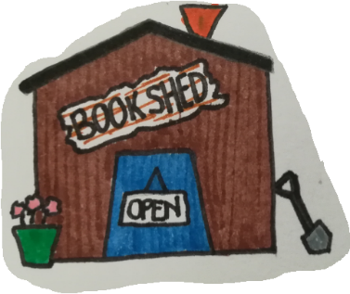
Book Shed Rewards
...earn a shed load of books!

Dear Parents / Carers,

At St Saviour’s, we reward children for reading with our very own school book shop called ‘The Book Shed’. Children earn 25p book tokens that can be spent on a fantastic range of brand-new books from ‘The Book Shed’ which opens at least once a long term (dates and times will be sent by letter).

How do children earn vouchers?
Each week, teachers will have vouchers to give out for specific reasons linked to reading, e.g. ‘most improved reader’ or ‘most enthusiastic about reading’! Pupils will also receive a voucher in addition to a certificate every time they achieve a star reader or a word count award. Children collect vouchers on a sheet which is stuck in the back of their reading record. Please look after these as we cannot replace lost vouchers!
What can vouchers be used for?
Vouchers can be spent in our school book shop: ‘The Book Shed’. We have a wide range of books for children to choose from including Horrid Henry, Horrible Histories and Wimpy Kid books as well as books from popular authors such as Jaqueline Wilson, Michael Morpurgo and David Walliams.
How much will books be?
Most of our books are 50% off the RRP on the back of the book and cost from £1 up to £5. The majority are priced at £3 - £4. Children will be able to save up their 25p vouchers to buy the book that they want or they can choose to top up their vouchers with money if they wish. They can also just buy the book if they want to save their vouchers for another time.
Will children be expected to bring in money?
No! Children can choose to top up their vouchers with money but we expect lots of children will want to save up their vouchers until they can afford the book that they would like. It is up to pupils whether they save up their vouchers to buy one of our cheaper books or wait a bit longer until they have enough vouchers for a more expensive book! We hope they will enjoy having a look to see what they want to save up for!

We hope that this will engage all children in reading and give everyone the opportunity to earn exciting books of their choice over the course of the year.

Mrs Grabiec and Mrs Kirkaldie
(Reading leads)

