Home Learning Projects Term 1
Please choose one project to complete with your child by
Monday 20th October to share with their class.

The Stone Age
Design and make a stone age house. It can be made out of anything.

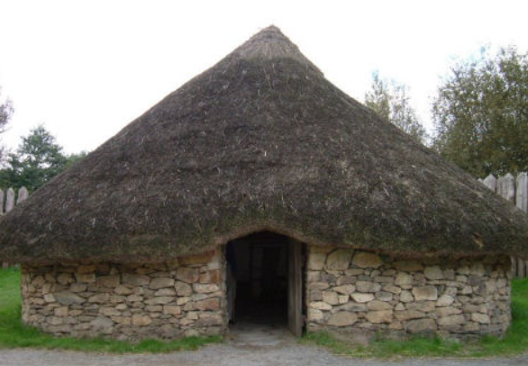

Art
Create your own piece of art using any medium you like!
You can use pencil, pastels, crayons, paints, digital software etc. 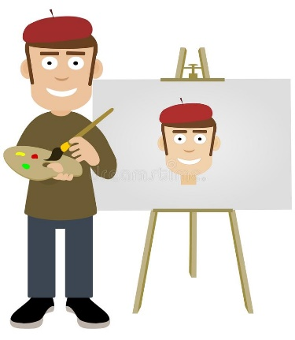

Thank you for your continued support,

The Year 3 Team

