Please complete at least 1 project for this term.
Geography

Research and create a fact file about the different biomes in the world.
OR…
If you are feeling creative, you could make a biome in a box!

Year 5 Home Learning: Term 1

Create a poster/fact file about your favourite Greek god or goddess.
What information can you include?
OR
Create a set of Top Trump cards for the Greek gods and goddesses.

History

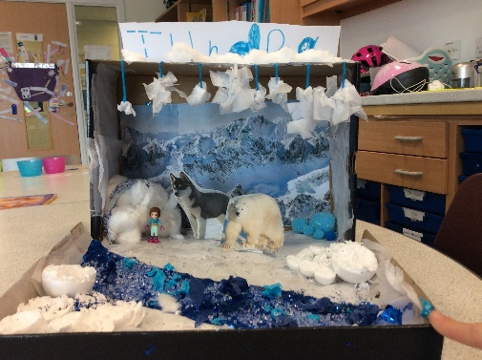
Create

Your Home Learning project needs to be in by Monday 13th October 2025
Weekly homework
- A minimum of 20 garage sessions must be completed weekly on Times Tables Rockstars. These will be set every Wednesday and due the following Wednesday.
- Please make sure that you read with your child and sign their home reading record at least three times a week.

Full PE kits should be worn to school every Tuesday and Wednesday (long hair should be tied back).
English

Have you read a great book over the summer or this term?
Write a review recommending your book to the class!

Remember!
R.E
Write about and draw someone special to you.
Explain why they are special.

