Please complete at least 1 project for this term.

Write a detailed set of instructions to explain how to make a family recipe.
Don’t forget to get adult supervision if you are cooking!

Year 6 Home Learning: Term 1

DT/ English

Propaganda was a persuasive technique used in WW2.
Research propaganda posters and create your own in a similar style.

History
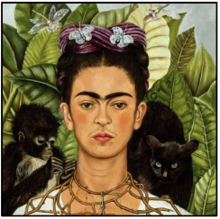

Create

From the point of view of a Christian, show the 7 days of creation. This can be done in any way you chose (eg. storyboard, story, comic strip, pictures, poster, leaflet).
ART

Create a self-portrait. Make sure to think about the background as well.
You can use anything you like to create this: pens, crayons, pencils, paint, the computer! The possibilities are endless.

Create a fact-file about the heart and circulatory system. You could include the functions of the heart, key nutrients our bodies need and ways to keep healthy.
Don’t forget to include a diagram or model of the heart!

R.E
Remember!

Your homework needs to be in by Monday 20th October 2025
Weekly homework
- A minimum of 20 garage sessions must be completed weekly on Times Tables Rock Stars. This is set every Wednesday and should be completed by the following Wednesday.
- Please make sure that you read with your child and sign their home reading record at least three times a week.

Full PE kits should be worn to school every Monday and Wednesday.
SCIENCE

Have you read a great book over the summer or this term?
Write a review recommending your book to the class!

