Wraparound Care
Join us for lots of fun this term including…

Hot Chocolate
Baking
Rainbow parachute games

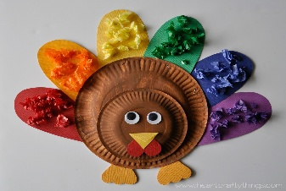
Mini trampolines
This Photo by Unknown Author is licensed under CC BY-NC-ND
Dodgeball
Dance
Crafts
Loom bands
Clay beads
Outdoor play and lots more…

Booking via ParentPay
£6 per child per session including a light tea including sandwiches, toast, toastie Tuesday, fruit, crisps, treats, yoghurt, squash and pizza Fridays
3.20pm – 5.45pm (you can collect before 5.45pm if you wish)








The Case of the Missing ____________
* Special Noun *
There once was a detective named ____________. One day, the
Name
detective's neighbor knocked on the door.

"I am so ____________," said the neighbor. "I can't find my ____________
Adjective * Special Noun *
anywhere. I saw it before I went to ____________ club, but later it was gone!"
Verb ending in "ing"
The detective grabbed a pencil and a ____________ and asked, "Will
Noun
you describe it?"

"Certainly," said the neighbor. "It is ____________, ____________, and
Color Adjective
it never ____________."
Plural verb
The detective searched ____________ around every ____________ and
Adverb Noun
behind every ____________.
Noun
"____________!" said the detective, "I found it! It was right here under
Exclamation
your ____________ the whole time!"
Noun
They both had a good ____________, and the detective thought,
Verb
"Another case ____________ solved!"
Adverb

Story Title
Ready to create your own Funny Fill-in story? To get started right away, just replace this text with your own. You can customize your story by adding your own pictures, shapes, and icons. On the Insert tab of the ribbon, just tap the option you need.  Once your story is complete, go back and replace the nouns, adjectives, adverbs, and other words with fill-in blanks. To create the fill-in blanks, just add a series of underscores, like this: ____________.  To add the labels, at the end of each line of your story, press Enter twice to create an empty paragraph between each line. Type the label text, and then select the Fill-In-Label style from the Styles gallery on the Home tab. Use tabs and spaces in front of the label to position it under the fill-in blank: ____________.  Fill-In Label  Get creative with your fill-in labels by using an Icon from the Insert tab in place of the label text. Resize and recolor the icons on the Format tab, and then select the Fill-In Icon style for the label paragraph:____________.    Stuck for story ideas? Get inspiration from a favorite story, fairytale, song, movie, or show. For a special occasion, such as a birthday or family get-together, write a story about the person or a funny family story. | 
 |  | 
 | 
 |  | 
 | 
 | 
 |  | 

