Dear Parents/ Carers,
As part of our World Book Day celebration on Thursday 5th March, we will be exploring a book called ‘Love is…’ which is a book full of beautiful animal similes and artwork celebrating love in all its different forms.
To link to this, children are invited to come to school dressed in an outfit they love. This can be as easy or elaborate as you would like to make it. For example, they can dress up in their favourite everyday outfit (casual, smart, football kit, pyjamas) or they might like to wear a uniform from a club they love or even dress as a character from a book they love. The possibilities are endless! We just ask that it is an outfit they will be safe in and appropriate for school.
We look forward to seeing everyone dressed in an outfit they love!
Thank you for your support with this,
Mrs Kirkaldie and Mrs Grabiec
(Reading leads)

COMPETITION TIME!
As a part of our World Book Day celebrations, we are also running a fun competition for any children who would like to enter. Children need to decorate a potato to look like a book character they love. This can be as simple or elaborate as they would like. Here are some examples in case you need some inspiration:
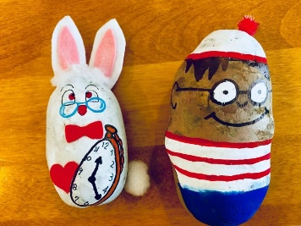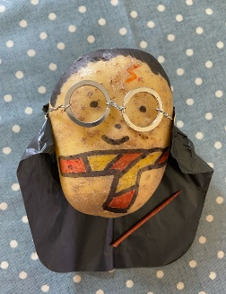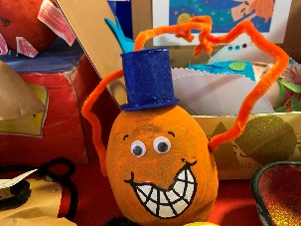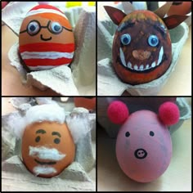

All the potato characters need to come into school on Thursday 5th March and we will take photos of them to put on display. A winning potato will be selected from lower school and upper school and the winning children will win a free book from the Book Shed. Please make sure they are named so we know who they all belong to.
Good luck and happy decorating!

