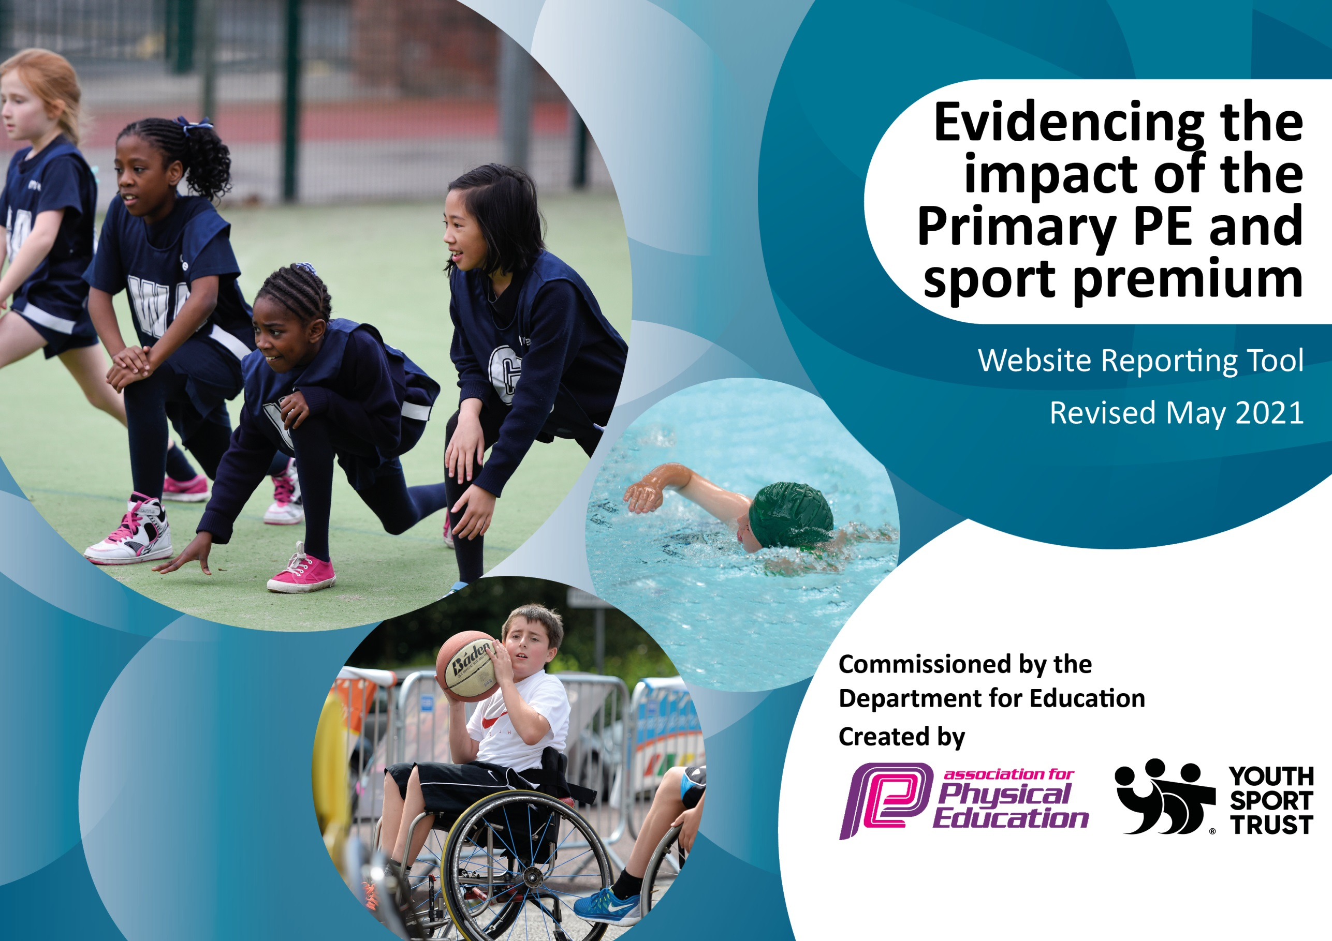

It is important that your grant is used effectively and based on school need. The Education Inspection Framework (Ofsted 2019 p64) makes clear there will be a focus on ‘whether leaders and those responsible for governors all understand their respective roles and perform these in a way that enhances the effectiveness of the school’.

Under the Quality of Education criteria (p41) inspectors consider the extent to which schools can articulate their curriculum (INTENT), construct their curriculum (IMPLEMENTATION) and demonstrate the outcomes which result (IMPACT).

To assist schools with common transferable language this template has been developed to utilise the same three headings which should make your plans easily transferable between working documents.

Schools must use the funding to make additional and sustainable improvements to the quality of Physical Education, School Sport and Physical Activity (PESSPA) they offer. This means that you should use the Primary PE and sport premium to:

- Develop or add to the PESSPA activities that your school already offer
- Build capacity and capability within the school to ensure that improvements made now will benefit pupils joining the school in future years
- The Primary PE and sport premium should not be used to fund capital spend projects; the school’s budget should fund these.
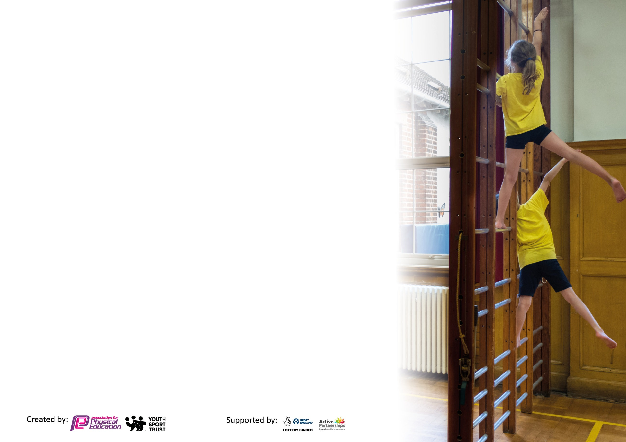
Please visit gov.uk for the revised DfE guidance including the 5 key indicators across which schools should demonstrate an improvement. This document will help you to review your provision and to report your spend. DfE encourages schools to use this template as an effective way of meeting the reporting requirements of the Primary PE and sport premium.

We recommend you start by reflecting on the impact of current provision and reviewing the previous spend.

Schools are required to publish details of how they spend this funding, including any under-spend from 2019/2020, as well as on the impact it has on pupils’ PE and sport participation and attainment by the end of the summer term or by 31st July 2021 at the latest.

We recommend regularly updating the table and publishing it on your website throughout the year. This evidences your ongoing self-evaluation of how you are using the funding to secure maximum, sustainable impact. Final copy must be posted on your website by the end of the academic year and no later than the 31st July 2021. To see an example of how to complete the table please click HERE.



Please note: Although there has been considerable disruption in 2020 it is important that you publish details on your website of how you spend the funding - this is a legal requirement.
Support for review and reflection - considering the 5 key indicators from DfE, what development needs are a priority for your setting and your pupils now and why? Use the space below to reflect on previous spend and key achievements and areas for development.

N.B. In this section you should refer to any adjustments you might have made due to Covid-19 and how these will influence further improvement.
Key achievements to date until July 2020: | Areas for further improvement and baseline evidence of need:
Due to Covid-19 we have been unable to provide a range of extra-curricular sporting clubs this academic year. However, since March 2021, our sports coach has delivered one extra-curricular sports club each week for each year group. This club has provided the opportunity for a third of the year group, at a time, to experience a range of different sports and activities with expert support and direction.  In addition to not being able to host our usual variety of extra-curricular sporting clubs this academic year we have also been unable to participate in any inter-school competitions. Nonetheless, our in-school sports coach has organised a range of intra-school and year group competitions. The children have had the chance to compete with basketball, football, tri-golf, tennis and cross-country events within their year group bubbles.  - Introduced a new scheme of work in September which has been well received and implemented across all year groups.  - Introduced a new method of formative and summative assessment which has been implemented in all year groups. | In 2021/2022 we aim to:  - Provide and organise a wider variety of extra-curricular activities that are delivered by expert coaches.  - Increased participation (from 2019/2020) in extra-curricular sporting activities.  - Achieve the Gold School Games Mark for 2021/2022  - Continue to use new assessment scheme.  - Improve facilities and equipment.  - Provide more regular opportunities for teacher CPD.

Did you carry forward an underspend from 2019-20 academic year into the current academic year? YES/NO * Delete as applicable
Total amount carried forward from 2019/2020 £11,573
+ Total amount for this academic year 2020/2021 £19,850
= Total to be spent by 31st July 2021 £31,423 (able to carry over remaining 2020/2021 funding to 2021/2022)
Meeting national curriculum requirements for swimming and water safety.

N.B Complete this section to your best ability. For example you might have practised safe self-rescue techniques on dry land which you can transfer to the pool when school swimming restarts.
Due to exceptional circumstances priority should be given to ensuring that pupils can perform safe self rescue even
if they do not fully meet the first two requirements of the NC programme of study.
What percentage of your current Year 6 cohort swim competently, confidently and proficiently over a distance of at least 25 metres?  N.B. Even though your pupils may swim in another year please report on their attainment on leaving primary school at the end of the summer term 2021.  Please see note above. | 60 %
What percentage of your current Year 6 cohort use a range of strokes effectively [for example, front crawl, backstroke and breaststroke]?  Please see note above. | 60 %
What percentage of your current Year 6 cohort perform safe self-rescue in different water-based situations? | 75 %
Schools can choose to use the Primary PE and sport premium to provide additional provision for swimming but this must be for activity over and above the national curriculum requirements. Have you used it in this way? | Yes/No

Action Plan and Budget Tracking
Capture your intended annual spend against the 5 key indicators. Clarify the success criteria and evidence of impact that you intend to measure to evaluate for pupils today and for the future.

Academic Year: 2020/21 | Total fund allocated: £30,397.71 | Date Updated: 12/07/21
Key indicator 1: The engagement of all pupils in regular physical activity – Chief Medical Officers guidelines recommend that primary school pupils undertake at least 30 minutes of physical activity a day in school |  |  |  | Percentage of total allocation:
 |  |  |  | 88 %
Intent | Implementation |  | Impact
Your school focus should be clear what you want the pupils to know and be able to do and about  what they need to learn and to  consolidate through practice: | Make sure your actions to achieve are linked to your intentions: | Funding allocated: | Evidence of impact: what do pupils now know and what can they now do? What has changed?: | Sustainability and suggested next steps:
Encourage active learning and active playtime opportunities to ensure children are benefiting from at least 30 minutes of physical activity in school every day.  Providing equipment to better the facilities available to staff and children. This will ensure lessons are challenging, engaging, stimulating and active. | Provide safe, appropriate and engaging equipment and facilities which are readily available for children to use. Henceforth, provide opportunities for children to be as physically active as possible throughout the school day.  Engaging children in PE lessons and after school activities through the purchase of new sporting equipment. | £26,889.11 | The purchase of new playground markings has enabled children to engage with more active play opportunities without modelling from adults.  New gym equipment installed on the playground has encouraged children to choose physical activity during break and lunch times.  The addition of playground barriers has enabled children to have designated areas to complete specific sporting activities in a safe environment. | The company who have created the new active play playground markings offer a 4-year warranty and 10-year guarantee. The current playground markings that have been replaced were installed in 1997 and have lasted for over 24 years.  The company who provided and installed the new gym equipment, ensure a 5-year warranty on paintwork, 2 years on bearings and 1 year on accessories. Regular monthly maintenance of the equipment will ensure all appliances are in good working order.  Playground barriers are very robust and made from a strong plastic that can withstand weathering.  Equipment is maintained and well looked after by children and staff to ensure expenditure of replacing equipment is kept to a minimum.  Utilise local secondary school facilities and equipment to provide engaging, fun filled and alternative opportunities for the children
Key indicator 2: The profile of PESSPA being raised across the school as a tool for whole school improvement |  |  |  | Percentage of total allocation:
 |  |  |  | 6 %
Intent | Implementation |  | Impact
Your school focus should be clear what you want the pupils to know and be able to do and about  what they need to learn and to  consolidate through practice: | Make sure your actions to achieve are linked to your intentions: | Funding allocated: | Evidence of impact: what do pupils now know and what can they now do? What has changed?: | Sustainability and suggested next steps:
Encourage children to show collaboration and teamwork by partaking in team events. Thus, promoting Christian and British Values and improving resilience, perseverance and sportsmanship. | Providing new sports kit to be worn at sporting events. Encouraging children to feel a part of a team and wider school community.  Reward the sporting achievements of children with medals and trophies of success. | £1,809.22 | Increased engagement, participation and excitement towards sporting activities. | New sporting kit was purchased in bulk in a variety of sizes to ensure every child in a team would have a kit to fit. Kits are allocated to individuals and are monitored upon return to ensure no kit is lost.  If sports premium funding was to be revoked then we would need to seek sponsorship for sporting rewards such as trophies and medals.

Key indicator 3: Increased confidence, knowledge and skills of all staff in teaching PE and sport |  |  |  | Percentage of total allocation:
 |  |  |  | 2 %
Intent | Implementation |  | Impact
Your school focus should be clear | Make sure your actions to | Funding | Evidence of impact: what do | Sustainability and suggested
what you want the pupils to know | achieve are linked to your | allocated: | pupils now know and what | next steps:
and be able to do and about | intentions: |  | can they now do? What has
what they need to learn and to |  |  | changed?:
consolidate through practice:
Increasing teacher confidence to deliver high quality lessons by providing clear learning objectives, well planned and high-quality lessons that provide opportunities for inclusion of all pupils. | Improved teacher confidence in delivering, planning and assessing PE lessons. Introducing a new scheme of work that uses modern technology to plan and assess lessons has provided teachers with flexibility in their instruction and confidence in their delivery.  Sports coordinator confidence increased after partaking in PE Deep Dive Training. | £719 | Children are now receiving lessons that are well planned and structured by teachers who are trained in the delivery of high-quality lessons.  PE action plan and planning document has been adapted and will be under regular review due to completed training. | Each year the subscription of our new scheme of work decreases in price. The technology that is used to deliver such lessons is looked after by assigned members of staff to ensure the likelihood of damage is reduced.  Implementing more regular staff meetings and training.
Key indicator 4: Broader experience of a range of sports and activities offered to all pupils |  |  |  | Percentage of total allocation:
 |  |  |  | 3 %
Intent | Implementation |  | Impact
Your school focus should be clear | Make sure your actions to | Funding | Evidence of impact: what do | Sustainability and suggested
what you want the pupils to know | achieve are linked to your | allocated: | pupils now know and what | next steps:
and be able to do and about | intentions: |  | can they now do? What has
what they need to learn and to |  |  | changed?:
consolidate through practice:
Engage with a range of different sporting activities i.e. lacrosse. | Purchase of equipment that is specific to a newly introduced sport.  Improved skills, fitness and passion for a new sport. | £979.98 | Actively engage with a variety of different sports and feel more confident to share knowledge, skills and understanding of a new sport. | Teachers to learn from specialist coaches and deliver extra-curricular clubs.  Establishing relationship with secondary schools to use their Sports students organise sessions.

Key indicator 5: Increased participation in competitive sport |  |  |  | Percentage of total allocation:
 |  |  |  | %
Intent | Implementation |  | Impact
Your school focus should be clear | Make sure your actions to | Funding | Evidence of impact: what do | Sustainability and suggested
what you want the pupils to know | achieve are linked to your | allocated: | pupils now know and what | next steps:
and be able to do and about | intentions: |  | can they now do? What has
what they need to learn and to |  |  | changed?:
consolidate through practice:
Due to Covid-19 we have been unable to participate in inter-school competitive sports. We have therefore utilised our funding to focus on the engagement of all pupils in regular physical activity, the profile of PESSPA being raised across the school, developing staff confidence skills and knowledge in PE and offer a range of sports and activities to all pupils.

Signed off by
Head Teacher:
Date:
Subject Leader: | Lauren Joy
Date: | 12.07.21
Governor:
Date:

